|  |  |  |  |  |  |
| --- | --- | --- | --- | --- | --- |
|  |  |  |  |  | logo1.png |

|  |  |  |  |
| --- | --- | --- | --- |
| **Course Name** | | **Zoho Books** | |
| **College Name** | | **Mangayarkarasi College of Arts and Science for Women Paravai, Madurai - 625002** | |
| **College Code** | | **MKU251** | |
| **Skill Offering Id** | |  | |
| **Project Title** | | **Preparation and maintenance of ZOHO books for urban aura interiors.** | |
| **Project Submitted To** | | **Madurai Kamaraj University ( Naan Mudhalvan Scheme(TNSDC))** | |
| **Year** | | **2023** | |
| **Department** | | **B.COM Computer Application** | |
| **Semester** | | **6** | |
| **Group Number** | | **4** | |
| **Total Members of the Group** | | **4** | |
| **Group Members Details** | | | |
| **Name of the Member** | **University Register. No** | | **Student NM ID** |
| **ABARNA.R** | **C1C15751** | | **C04654E948389228CF741C47030E1E31** |
| **GOKILA RAMALAKSHMI.S** | **C1C15756** | | **75B0520C3106BB4B81044ECF9C273AA2** |
| **SREE VARSHINI.R** | **C1C15782** | | **087BABCBD3D41D4BDE743B2A713C8624** |
| **SUBANU.K** | **C1C15785** | | **E00ACCCCFA568DC81F147BD23D31A72E** |
|  |  | |  |
| **Under the Guidance** | |  | |
| **SPOC** | | **Ms.P.UMADEVI** | |

**EMPATHY MAP:**

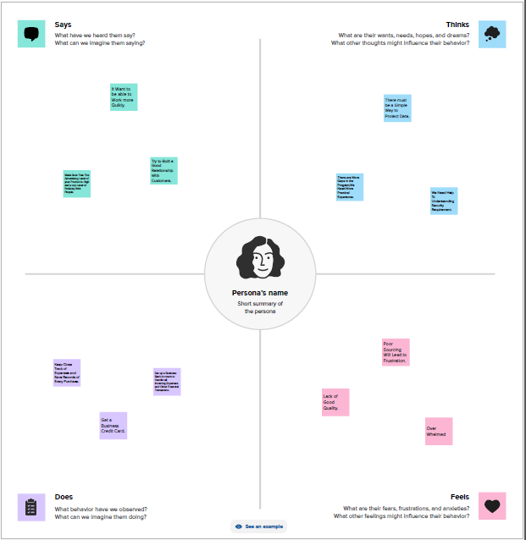

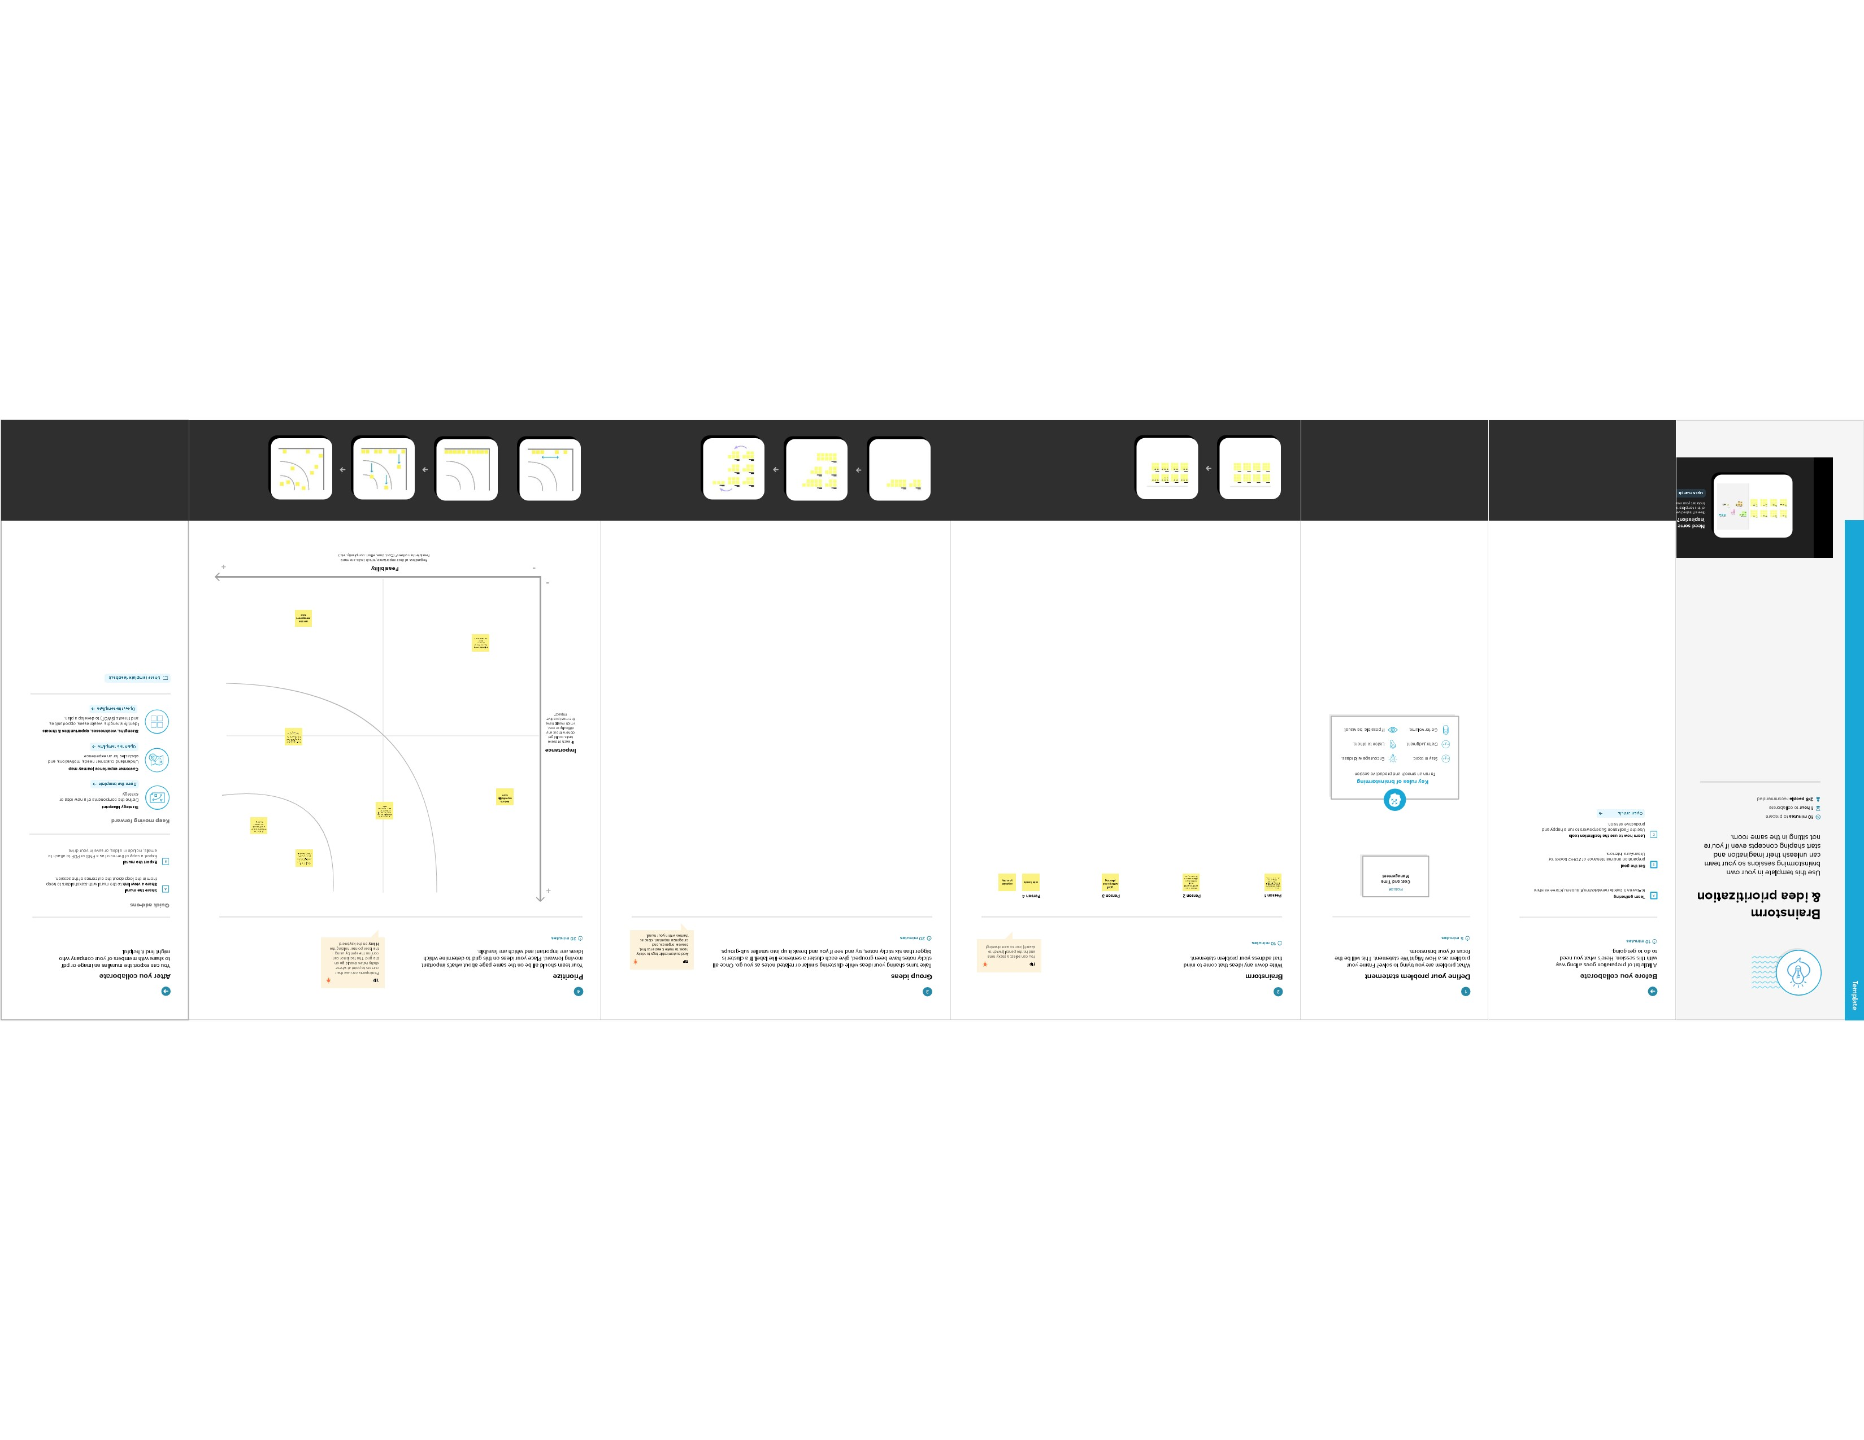**BRAIN STROMING:**

